* A segunda chain tem como funções moleculares:
* [catalytic activity](https://www.rcsb.org/search?q=rcsb_polymer_entity_annotation.annotation_lineage.name:catalytic%20activity&rt=polymer_entity)
* [carboxypeptidase activity](https://www.rcsb.org/search?q=rcsb_polymer_entity_annotation.annotation_lineage.name:carboxypeptidase%20activity&rt=polymer_entity)
* [peptidase activity](https://www.rcsb.org/search?q=rcsb_polymer_entity_annotation.annotation_lineage.name:peptidase%20activity&rt=polymer_entity)
* [exopeptidase activity](https://www.rcsb.org/search?q=rcsb_polymer_entity_annotation.annotation_lineage.name:exopeptidase%20activity&rt=polymer_entity)
* [hydrolase activity](https://www.rcsb.org/search?q=rcsb_polymer_entity_annotation.annotation_lineage.name:hydrolase%20activity&rt=polymer_entity)
* [catalytic activity, acting on a protein](https://www.rcsb.org/search?q=rcsb_polymer_entity_annotation.annotation_lineage.name:catalytic%20activity,%20acting%20on%20a%20protein&rt=polymer_entity)
* [endopeptidase activity](https://www.rcsb.org/search?q=rcsb_polymer_entity_annotation.annotation_lineage.name:endopeptidase%20activity&rt=polymer_entity)
* [metallocarboxypeptidase activity](https://www.rcsb.org/search?q=rcsb_polymer_entity_annotation.annotation_lineage.name:metallocarboxypeptidase%20activity&rt=polymer_entity)
* [metalloexopeptidase activity](https://www.rcsb.org/search?q=rcsb_polymer_entity_annotation.annotation_lineage.name:metalloexopeptidase%20activity&rt=polymer_entity)
* [metallopeptidase activity](https://www.rcsb.org/search?q=rcsb_polymer_entity_annotation.annotation_lineage.name:metallopeptidase%20activity&rt=polymer_entity)
* [peptidyl-dipeptidase activity](https://www.rcsb.org/search?q=rcsb_polymer_entity_annotation.annotation_lineage.name:peptidyl-dipeptidase%20activity&rt=polymer_entity)
* [binding](https://www.rcsb.org/search?q=rcsb_polymer_entity_annotation.annotation_lineage.name:binding&rt=polymer_entity)
* [zinc ion binding](https://www.rcsb.org/search?q=rcsb_polymer_entity_annotation.annotation_lineage.name:zinc%20ion%20binding&rt=polymer_entity)
* [ion binding](https://www.rcsb.org/search?q=rcsb_polymer_entity_annotation.annotation_lineage.name:ion%20binding&rt=polymer_entity)
* [cation binding](https://www.rcsb.org/search?q=rcsb_polymer_entity_annotation.annotation_lineage.name:cation%20binding&rt=polymer_entity)
* [metal ion binding](https://www.rcsb.org/search?q=rcsb_polymer_entity_annotation.annotation_lineage.name:metal%20ion%20binding&rt=polymer_entity)
* [transition metal ion binding](https://www.rcsb.org/search?q=rcsb_polymer_entity_annotation.annotation_lineage.name:transition%20metal%20ion%20binding&rt=polymer_entity)
* The second chain was Biological Process, the first one doesn’t have it, the Biological process are:
* [metabolic process](https://www.rcsb.org/search?q=rcsb_polymer_entity_annotation.annotation_lineage.name:metabolic%20process)
* [positive regulation of metabolic process](https://www.rcsb.org/search?q=rcsb_polymer_entity_annotation.annotation_lineage.name:positive%20regulation%20of%20metabolic%20process)
* [cellular process](https://www.rcsb.org/search?q=rcsb_polymer_entity_annotation.annotation_lineage.name:cellular%20process)
* [regulation of metabolic process](https://www.rcsb.org/search?q=rcsb_polymer_entity_annotation.annotation_lineage.name:regulation%20of%20metabolic%20process)
* [regulation of cellular metabolic process](https://www.rcsb.org/search?q=rcsb_polymer_entity_annotation.annotation_lineage.name:regulation%20of%20cellular%20metabolic%20process)
* [positive regulation of cellular metabolic process](https://www.rcsb.org/search?q=rcsb_polymer_entity_annotation.annotation_lineage.name:positive%20regulation%20of%20cellular%20metabolic%20process)
* [cellular metabolic process](https://www.rcsb.org/search?q=rcsb_polymer_entity_annotation.annotation_lineage.name:cellular%20metabolic%20process)
* [positive regulation of biological process](https://www.rcsb.org/search?q=rcsb_polymer_entity_annotation.annotation_lineage.name:positive%20regulation%20of%20biological%20process)
* [positive regulation of cellular process](https://www.rcsb.org/search?q=rcsb_polymer_entity_annotation.annotation_lineage.name:positive%20regulation%20of%20cellular%20process)
* [regulation of biological process](https://www.rcsb.org/search?q=rcsb_polymer_entity_annotation.annotation_lineage.name:regulation%20of%20biological%20process)
* [regulation of cellular process](https://www.rcsb.org/search?q=rcsb_polymer_entity_annotation.annotation_lineage.name:regulation%20of%20cellular%20process)
* [biological regulation](https://www.rcsb.org/search?q=rcsb_polymer_entity_annotation.annotation_lineage.name:biological%20regulation)
* [reactive oxygen species metabolic process](https://www.rcsb.org/search?q=rcsb_polymer_entity_annotation.annotation_lineage.name:reactive%20oxygen%20species%20metabolic%20process)
* [regulation of reactive oxygen species metabolic process](https://www.rcsb.org/search?q=rcsb_polymer_entity_annotation.annotation_lineage.name:regulation%20of%20reactive%20oxygen%20species%20metabolic%20process)
* [positive regulation of reactive oxygen species metabolic process](https://www.rcsb.org/search?q=rcsb_polymer_entity_annotation.annotation_lineage.name:positive%20regulation%20of%20reactive%20oxygen%20species%20metabolic%20process)
* [viral process](https://www.rcsb.org/search?q=rcsb_polymer_entity_annotation.annotation_lineage.name:viral%20process)
* [viral life cycle](https://www.rcsb.org/search?q=rcsb_polymer_entity_annotation.annotation_lineage.name:viral%20life%20cycle)
* [virion attachment to host cell](https://www.rcsb.org/search?q=rcsb_polymer_entity_annotation.annotation_lineage.name:virion%20attachment%20to%20host%20cell)
* [biological adhesion](https://www.rcsb.org/search?q=rcsb_polymer_entity_annotation.annotation_lineage.name:biological%20adhesion)
* [biological process involved in symbiotic interaction](https://www.rcsb.org/search?q=rcsb_polymer_entity_annotation.annotation_lineage.name:biological%20process%20involved%20in%20symbiotic%20interaction)
* [adhesion of symbiont to host](https://www.rcsb.org/search?q=rcsb_polymer_entity_annotation.annotation_lineage.name:adhesion%20of%20symbiont%20to%20host)
* [biological process involved in interspecies interaction between organisms](https://www.rcsb.org/search?q=rcsb_polymer_entity_annotation.annotation_lineage.name:biological%20process%20involved%20in%20interspecies%20interaction%20between%20organisms)
* [adhesion of symbiont to host cell](https://www.rcsb.org/search?q=rcsb_polymer_entity_annotation.annotation_lineage.name:adhesion%20of%20symbiont%20to%20host%20cell)
* [receptor-mediated virion attachment to host cell](https://www.rcsb.org/search?q=rcsb_polymer_entity_annotation.annotation_lineage.name:receptor-mediated%20virion%20attachment%20to%20host%20cell)
* [cell population proliferation](https://www.rcsb.org/search?q=rcsb_polymer_entity_annotation.annotation_lineage.name:cell%20population%20proliferation)
* [regulation of cell population proliferation](https://www.rcsb.org/search?q=rcsb_polymer_entity_annotation.annotation_lineage.name:regulation%20of%20cell%20population%20proliferation)
* [entry into host](https://www.rcsb.org/search?q=rcsb_polymer_entity_annotation.annotation_lineage.name:entry%20into%20host)
* [viral entry into host cell](https://www.rcsb.org/search?q=rcsb_polymer_entity_annotation.annotation_lineage.name:viral%20entry%20into%20host%20cell)
* [biological process involved in interaction with host](https://www.rcsb.org/search?q=rcsb_polymer_entity_annotation.annotation_lineage.name:biological%20process%20involved%20in%20interaction%20with%20host)
* [movement in host environment](https://www.rcsb.org/search?q=rcsb_polymer_entity_annotation.annotation_lineage.name:movement%20in%20host%20environment)

A parte de Baixo é que conta :D

---------------------------------------------------------------------------------------------------------------------------------

#Lido de um artigo nas features...

Fazendo a alteração na lysine na posição 31 e da tyrosina na posição 41, podemos detetar que se reduzia significantemente a associação com a com a proteína S1-Ig do COVID, e também lysine 353, aspartic 355, arginine 357.

ACE2 filogeny <https://www.ensembl.org/Multi/GeneTree/Image?gt=ENSGT00940000158077>

Name=ACE2

ORFNames=UNQ868/PRO1885

Entry_name:ACE2_HUMAN

Seq_length:805

OrganismClass:['Eukaryota', 'Metazoa', 'Chordata', 'Craniata', 'Vertebrata', 'Euteleostomi', 'Mammalia', 'Eutheria', 'Euarchontoglires', 'Primates', 'Haplorrhini', 'Catarrhini', 'Hominidae', 'Homo']

Organism:'Homo sapiens (Human).'

Taxonomy:['9606']

FUNCTION: Essential counter-regulatory carboxypeptidase of the renin- angiotensin hormone system that is a critical regulator of blood volume, systemic vascular resistance, and thus cardiovascular homeostasis. Converts angiotensin I to angiotensin 1- 9, a nine-amino acid peptide with anti-hypertrophic effects in cardiomyocytes, and angiotensin II to angiotensin 1-7, which then acts as a beneficial vasodilator and anti-proliferation agent, counterbalancing the actions of the vasoconstrictor angiotensin II. Also removes the C-terminal residue from three other vasoactive peptides, neurotensin, kinetensin, and des-Arg bradykinin, but is not active on bradykinin. Also cleaves other biological peptides, such as apelins (apelin-13, [Pyr1]apelin-13, apelin-17, apelin-36), casomorphins (beta-casomorphin- 7, neocasomorphin) and dynorphin A with high efficiency. In addition, ACE2 C-terminus is homologous to collectrin and is responsible for the trafficking of the neutral amino acid transporter SL6A19 to the plasma membrane of gut epithelial cells via direct interaction, regulating its expression on the cell surface and its catalytic activity.

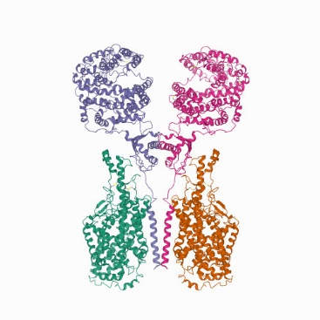 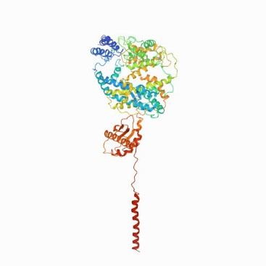

#### In the right we have the complex of the genes ACE2-B0AT1, and in the left we have only the complex of the protein in study the ACE2

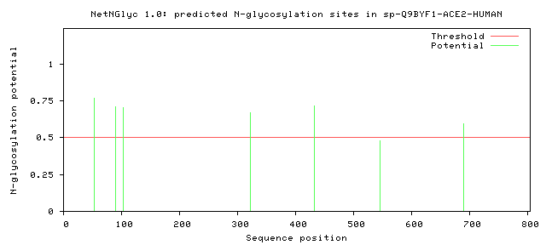

Utilizando o software NetNGlyc, podemos ver o numero de N-glicosisações, verificou-se a existencia de 6 N glicolisações nas posições 53,90,103,322,432,690.

Sendo na posição 90 uma glicolisação que diminui a infecciosidade da Proteína S

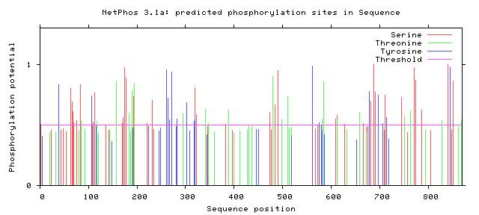

Utilizando o software NetPhos, podemos detetar o número de Fosforilações que podes ocorrer na nossa proteína, e podemos ver pelo nosso gráfico um número elevado de fosforilações que podem ocorrer na nossa proteína ACE2.



Utilizando o software LocTree 3, que prevê a localização subcelular de proteínas, inferiu-se que a proteína é secretada, e que se encontrada agregado aos termos GO: espaço extracelular e membrana.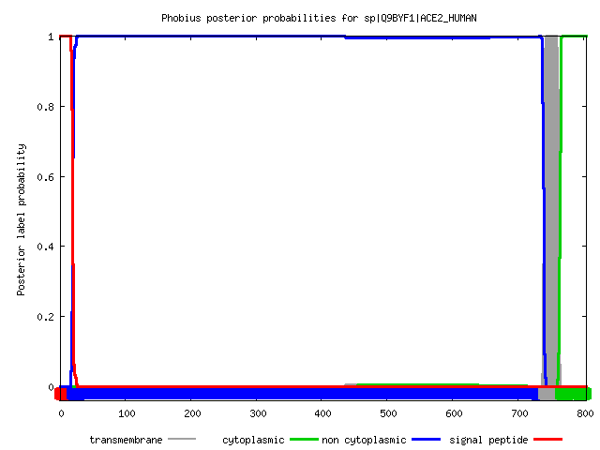

A partir do Phobius podemos ver que esta proteína só contem 1 domínio transmembranar.